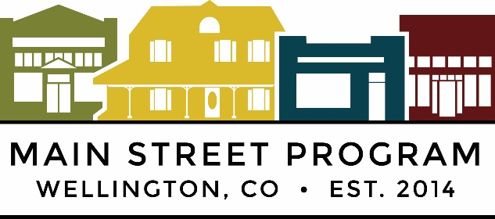

PROJECT:2025 National Clean-Up Day
DATE: Saturday, September 20
LOCATION: Downtown, Frontage Road, Free Dumpsters on 6th Street

Please read and sign below. You must return this before you can participate in the event.

Statement of Agreement:
I, the undersigned, agree to VOLUNTEER with the Town of Wellington and Wellington Main Street Program. I understand that the activities involved with the program contain an element of hazard or risk. I recognize the inherent danger involved and take full responsibility for my actions and physical condition.

I agree to indemnify and hold the Town of Wellington and Wellington Main Street Program, and any cooperating agencies involved in the activities and any of their agents, officials, or employees free and harmless from any liability, loss, cost or expense including attorney fees which may result from participation in the activities. I agree that I am fully responsible for payment of all costs resulting from the rendering of medical aid and ambulance services, and I authorize that all necessary first aid steps may be taken as prescribed by qualified personnel. I grant full permission to use any photographs, videotapes, recording or any other record of this program for any purpose. By signing below, I agree that I understand and consent to this statement.

__________________________________________________________________
Printed Name of Participant Date

___________________________________________________________________
Address City Zip Phone number

___________________________________________________________________
Signature of Participant Date of Birth

____________________________________________________________________
If Youth is under 18, Signature of Legal Guardian

In Case of Emergency Contact:________________________ Phone:_______________

